**HAP618 -FALL2023**

COMPUTATIONAL TOOLS USED IN HEALTH INFORMATICS

**FINAL PROJECT PAPER**

**TOPIC-** DENTAL CLINIC WEBSITE WITH APPOINTMENT BOOKING SYSTEM.

LAKSHMI INDIRA KUPPA

G01451480

TABLE OF CONTENTS-

1.BACKGROUND

2. PRIMARY OBJECTIVES

3.PROJECT OVERVIEW- Key features

- Technologies used

4.IMPLEMENTATION - Design and Code used.

5. RESULTS AND FUNCTIONALITY DEMONSTRATION

6.CHALLENGES AND SOLUTIONS

7.FUTURE ENHANCEMENTS

8.CONCLUSION

9. LESSONS LEARNED

10.REFERENCES

**BACKGROUND**

The healthcare industry is experiencing a paradigm shift towards digital solutions that offer convenience and accessibility to patients. This digital transformation is reshaping patient expectations and service delivery. The traditional method of scheduling appointments and managing patient information in dental clinics often involves manual processes that can be time-consuming and prone to errors. In response to the evolving needs of patients and healthcare providers, there is a growing demand for innovative platforms that leverage technology to streamline processes and improve the overall patient experience. This project addresses the growing need for convenient healthcare solutions, particularly in the context of dental care. By leveraging Python, the platform aims to streamline appointment scheduling, improve patient engagement, and empower dental clinics to deliver personalized care.

**PRIMARY OBJECTIVES**

1. To create a user-friendly web application for booking dental appointments.

2. To implement a responsive and visually appealing user interface.

3.To explore Technologies like Python, Flask, HTML and CSS.

**PROJECT OVERVIEW**

KEY FEATURES-

1. Demographic & Diagnostic Questionnaire: The platform will guide patients through a series of questions related to their chief complaints, ensuring that dentists have essential information before the scheduled appointment.

2. Appointment Booking System: Patients can schedule appointments with the dental clinic through an interactive and user-friendly interface, providing them with the flexibility to choose suitable time slots.

3. User Profiles and Database: The system will maintain comprehensive patient information, including demographic information and appointment history. This data is stored in an excel file so that dentists can access relevant patient data, enabling them to provide personalized and efficient care.

4.Efficiency and Patient Experience: By digitizing the appointment scheduling process and integrating diagnostic questionnaires, the platform aims to enhance the overall efficiency of dental clinics and improve the patient experience.

TECHNOLOGIES USED-

Python: Chosen for its versatility and compatibility with Flask, Python serves as the primary backend language, handling the logic behind appointment scheduling, data processing, and user interactions.

Flask: A micro web framework in Python, Flask is utilized for web development. It enables the creation of dynamic and interactive web pages, facilitating a seamless user experience for patients interacting with the platform.

Excel: Excel is employed as the database solution for storing patient information and appointment history. While unconventional, this choice provides a familiar interface for data management and allows for easy integration with existing office workflows.

HTML and CSS: HTML is employed for structuring the web pages, defining the content and layout, while CSS is used for styling and enhancing the visual presentation. Together, they contribute to the creation of an intuitive and user-friendly interface.

**IMPLEMENTATION**

* A virtual environment allows us to create an isolated environment for our Python project. This means that the dependencies (libraries and packages) required for our project are installed and maintained separately from the system-wide Python installation. This isolation helps prevent conflicts between different projects that may require different versions of the same library. By incorporating virtual environments into our Python development workflow, we ensure a clean, organized, and reproducible environment for each of our projects.
* For activating virtual environment, we use source venv\Scripts\activate
* I will be using GitBash for running the Python code.
* And I will be using Sublime Text Editor as the primary text editor for code development. (Python,Html,CSS)
* Managing data storage and retrieval within the Excel spreadsheet.
* The static folder is where we store the static files such as CSS stylesheets (style.css) and images.
* The templates folder contains the HTML templates, including layout.html, index.html, and other templates.
* The __init__.py, forms.py, models.py, and routes.py files are part of your Flask application.
* run.py is a script to run your Flask application.

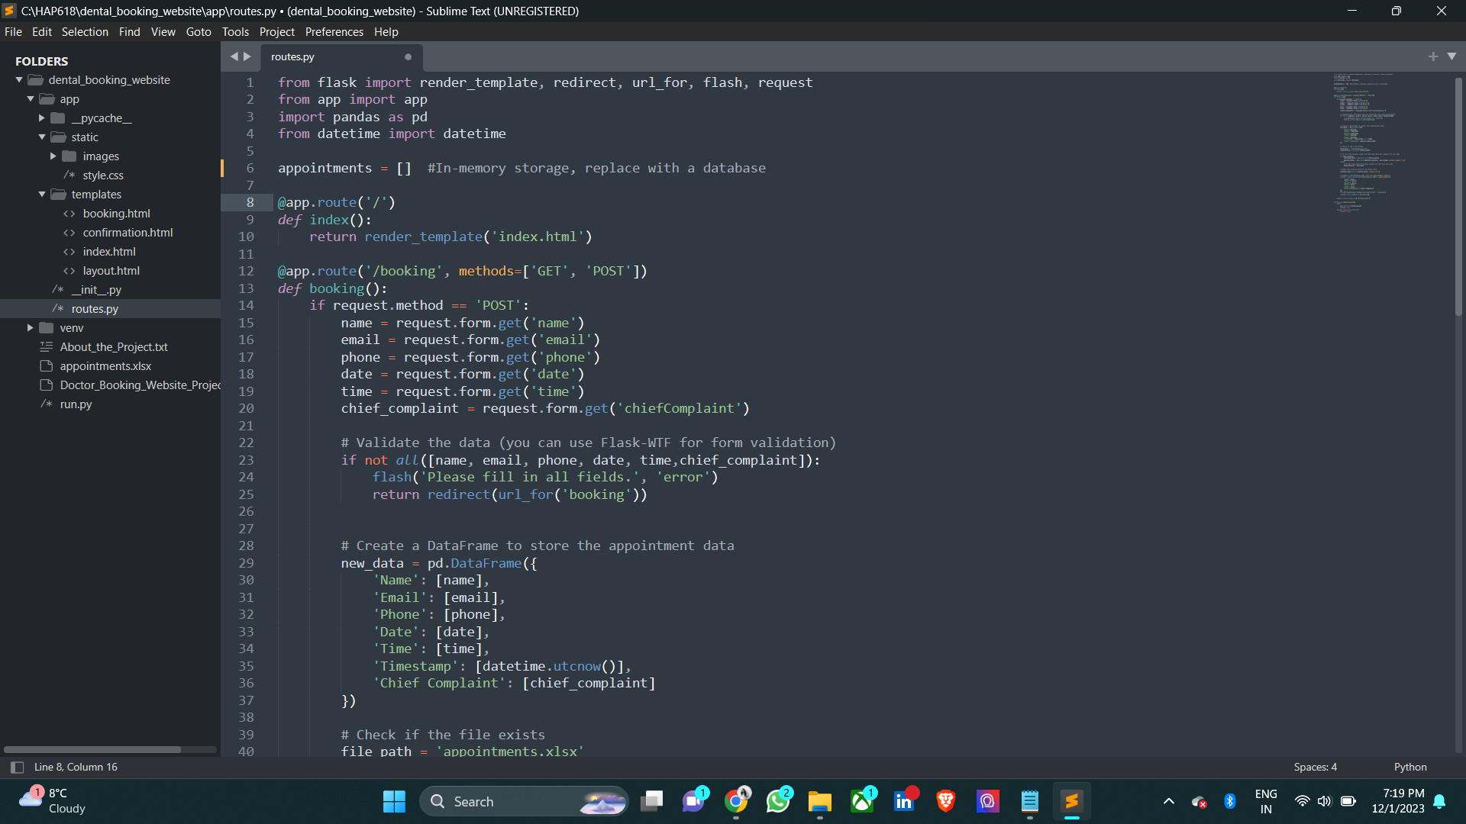

The Python code represents the backend logic of the dental appointment booking system using the Flask web framework. The system allows users to input their details, book appointments, and stores the information in an Excel file.

1. Flask Routes:

@app.route('/') - Home Route: This route renders the home page (index.html) when the user navigates to the root URL.

@app.route('/booking', methods=['GET', 'POST']) - Booking Route: Handles both GET and POST requests for the booking page.

For a POST request (form submission), it collects user input (name, email, phone, date, time, chief complaint).

2. Data Validation:

The code validates the form data to ensure that all fields are filled out. If any field is missing, an error message is flashed, and the user is redirected back to the booking page.

3. Data Storage: In-memory Storage:

An in-memory list (appointments) is used for temporary storage. This should be replaced with a database for a more robust solution.

DataFrame Creation: A Pandas DataFrame (new_data) is created with the user's appointment details, including a timestamp.

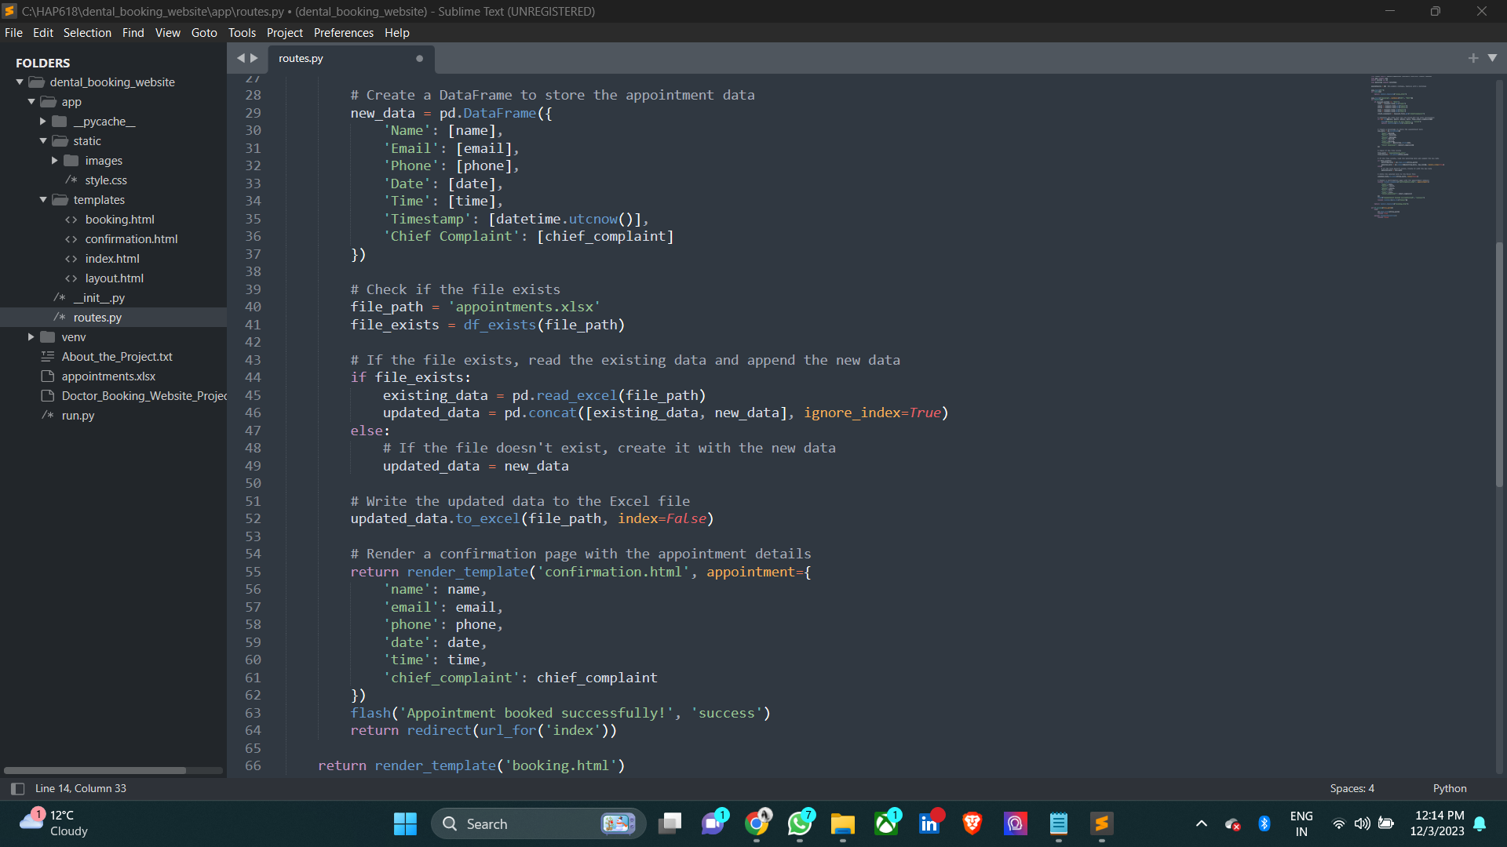

File Existence Check: Checks if the Excel file (appointments.xlsx) already exists using the df_exists function.

Data Concatenation: If the file exists, the new data is concatenated with the existing data. If not, a new DataFrame (updated_data) is created.

Data Storage to Excel: The updated data is written to the Excel file (appointments.xlsx).

4. Rendering Confirmation Page:

After successful booking, a confirmation page (confirmation.html) is rendered, displaying the appointment details.

5. Flash Messages:

Flash messages are used to provide feedback to the user, indicating whether the appointment was booked successfully or if there were errors.

6. df_exists Function: This function checks if a file exists using a try-except block. It returns True if the file exists and False if it doesn't.

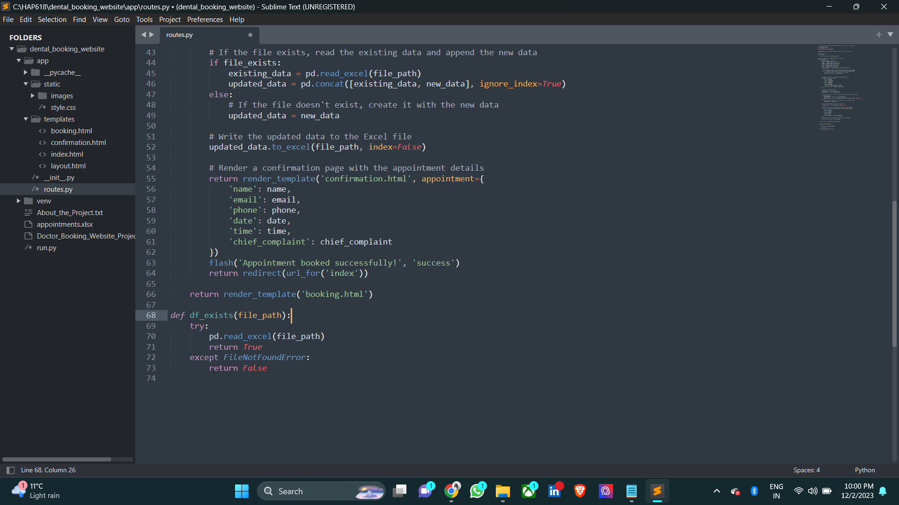

**HTML CODE**

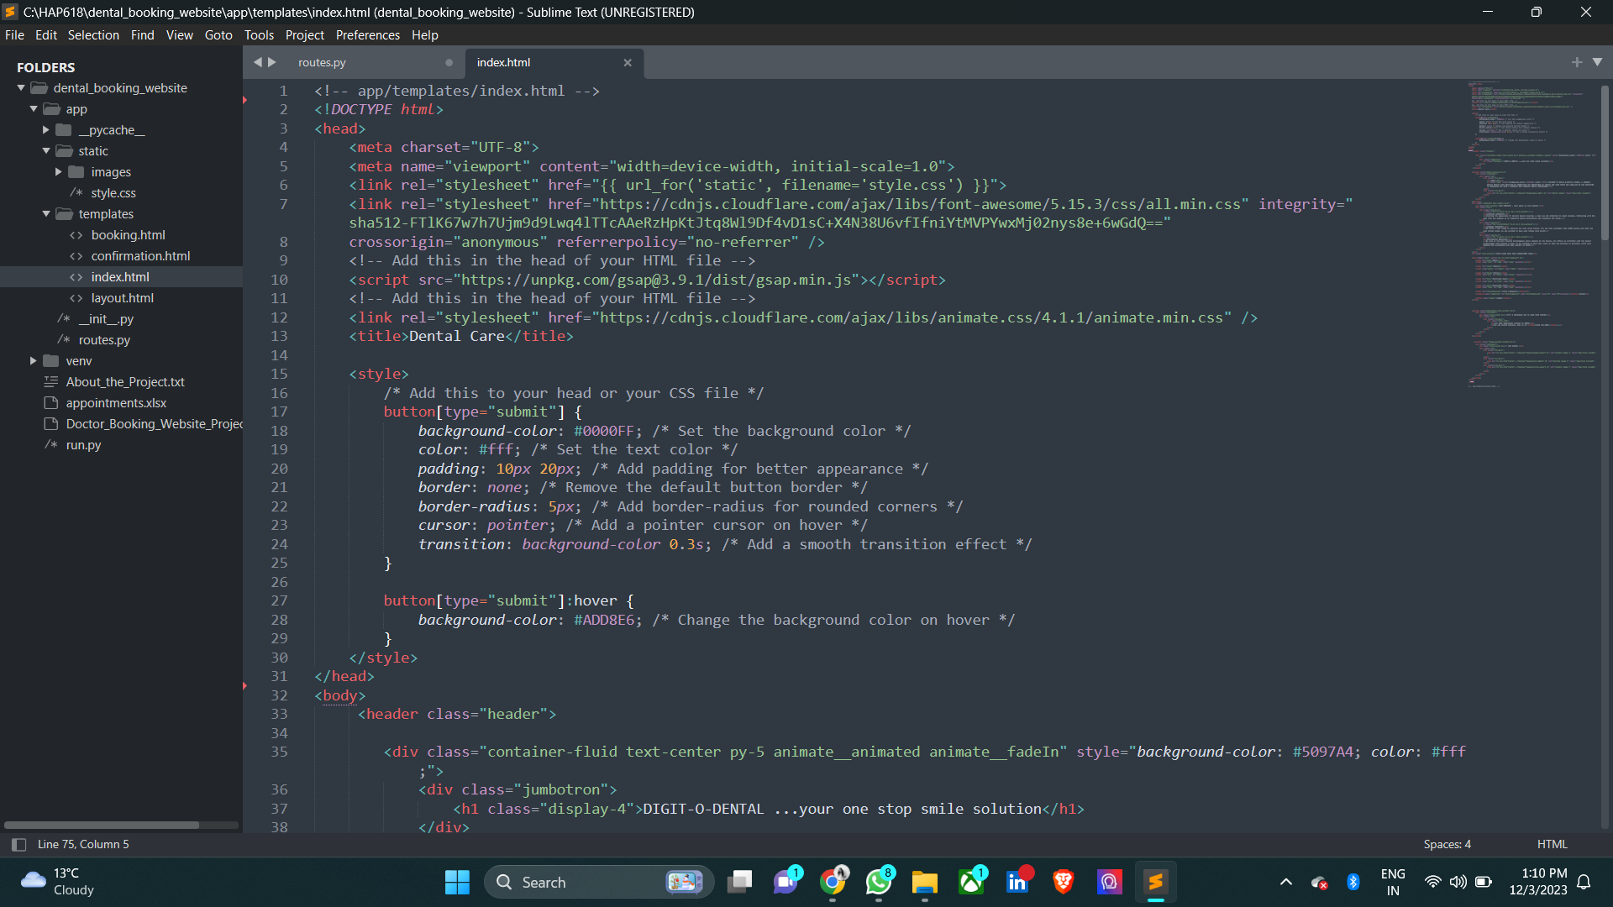

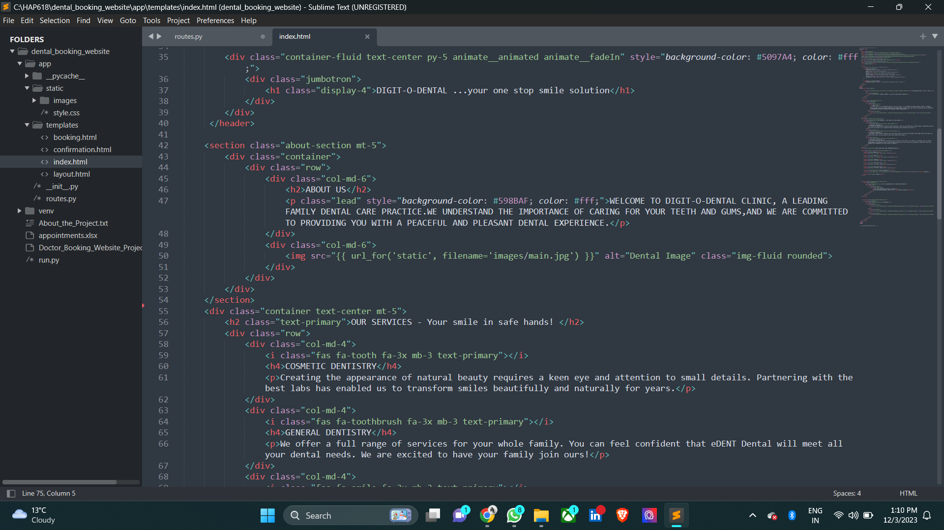

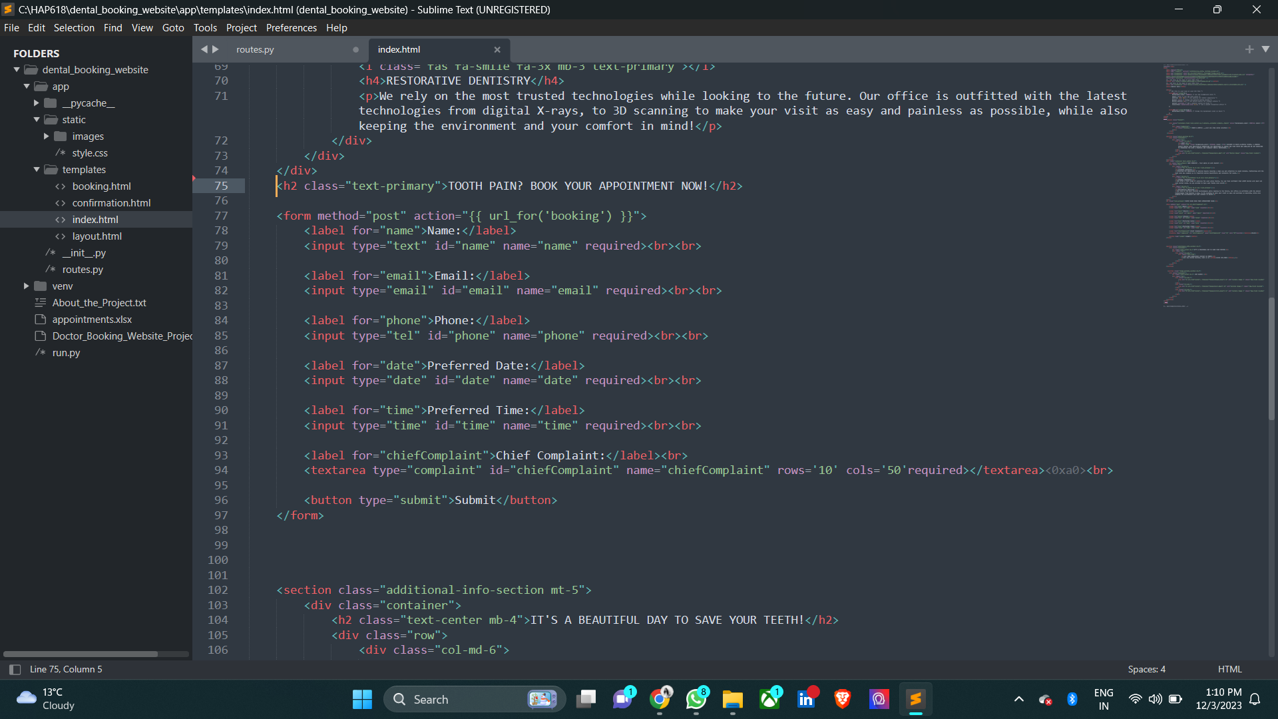

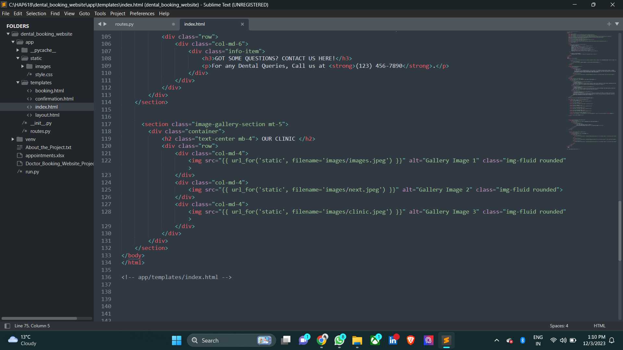

**RESULTS AND DEMONSTRATION FUNCTIONALITY**

This presents the webpage of the Clinic, which is ‘index.html’.

The patient details are given and when we hit the submit button.

A new confirmation page is redirected where the confirmed details are displayed. Below are the screenshots of the process. And these details are stored in an Excel file.

The index page contains number of sub-sections like

1. About us
2. Our services
3. Appointment section
4. Additional contact information
5. Clinic images

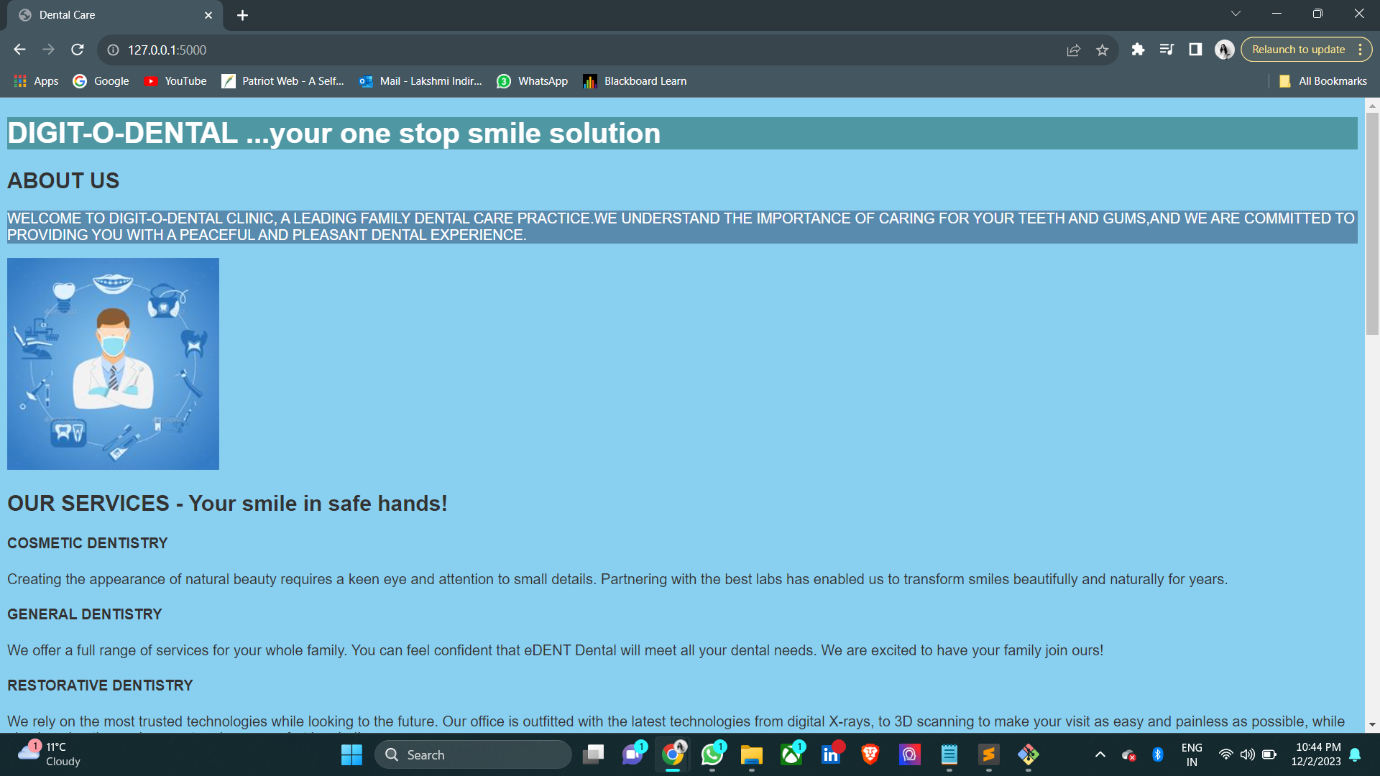

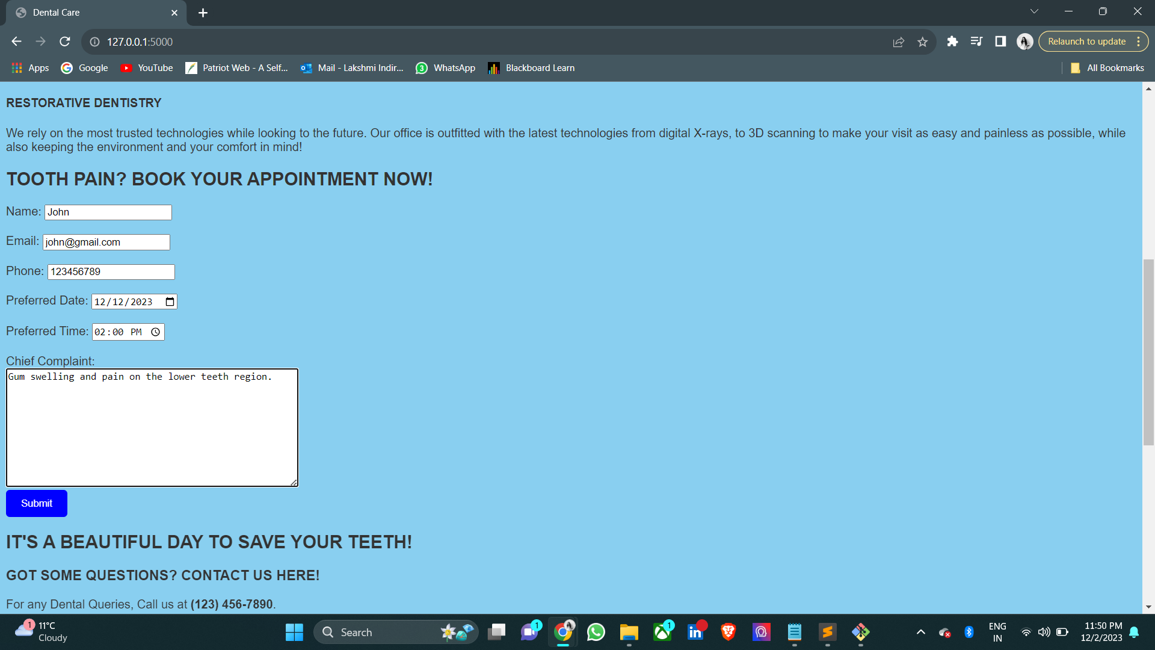

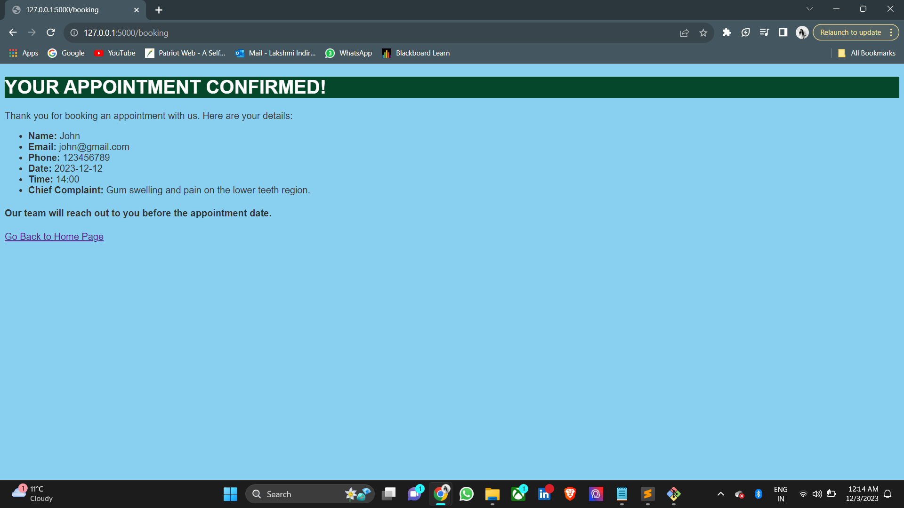

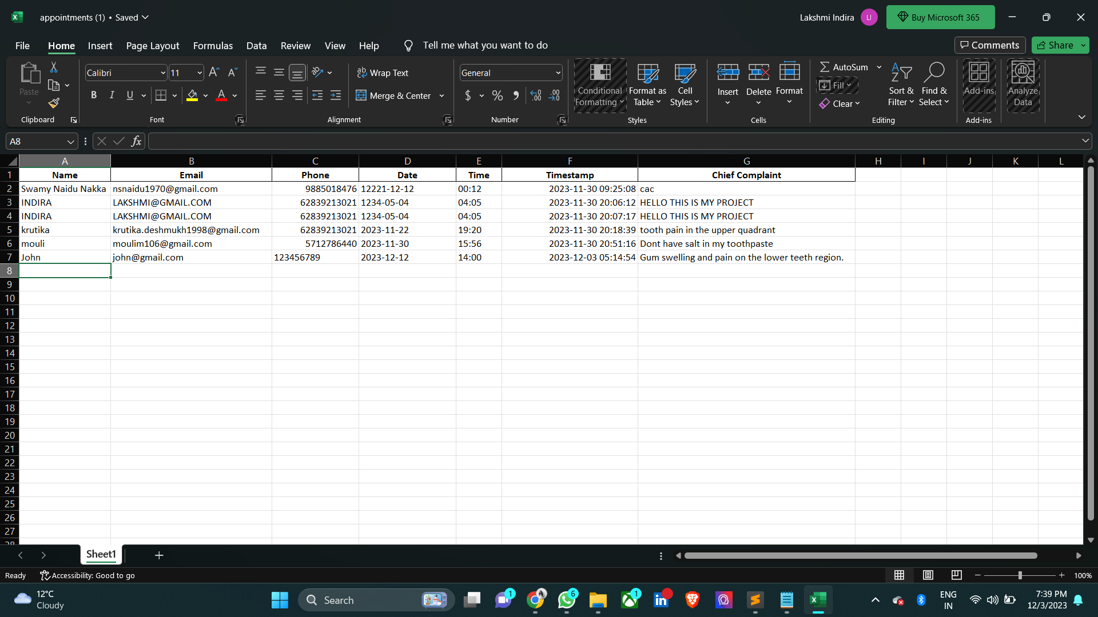

**CHALLENGES AND SOLUTIONS**

1. Challenge: Using an Excel file for data storage may pose scalability issues as the number of appointments increases.This can be solved by Migrating from Excel-based storage to a relational database (e.g., PostgreSQL, MySQL) for improved scalability and data management.

2. Challenge: Limited security measures, such as lack of input validation, could expose the system to vulnerabilities. This is combatted by implementing robust security measures, such as input validation, to mitigate potential vulnerabilities and enhance data integrity.

3. Challenge: The system might lack features for users to interact beyond booking appointments, such as reviewing or modifying their appointments. This can be solved by introducing user authentication and profiles to enhance user interaction. Users can view, modify, or cancel appointments through personalized dashboards.

**FUTURE ENHANCEMENTS**

1. We can implement a user authentication system to allow patients and clinic staff to have personalized profiles.
2. Integrate a notification system to send reminders and confirmations to patients about upcoming appointments.
3. Allow patients to choose their preferred notification methods (email, SMS, app notifications).
4. Extend the system to support online consultations and telemedicine services for patients who may prefer virtual appointments.
5. Make the system accessible to a wider audience by implementing multi-language support.

**LESSONS LEARNT**

1. Various python libraries
2. About flask framework web development
3. Use of Bootstrap for the front-end web development.
4. Use of Html and CSS for visual presentation.

**REFERENCES**

1. <https://flask.palletsprojects.com/>): Official documentation for the Flask web framework.
2. <https://getbootstrap.com/docs/5.1/>): Documentation for the Bootstrap framework, which provides styles and components for building responsive web pages.
3. https://pandas.pydata.org/pandas-docs/stable/): Pandas library, which is used for data manipulation and analysis.
4. <https://animate.style/>: A library for adding CSS animations to HTML elements
5. [www.google.com](http://www.google.com/) for the images
6. Class notes for Python and html codes.